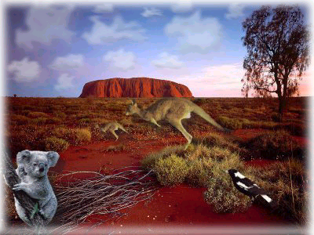
AUSTRALIA : A WEBQUEST

- Complete the map and colour France in blue and Australia in red. http://www.enchantedlearning.com/geography/label/labelcontinentsanswers.shtml

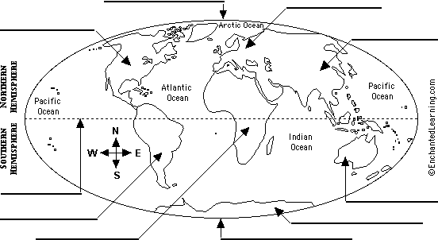

AFRICA – ANTARTICA - ASIA – AUSTRALIA – EQUADOR – EUROPE – NORTH AMERICA – NORTH POLE – SOUTH AMERICA – SOUTH POLE -

- Which hemisphere is Australia in ? ……………………………………………………………………………….

- So, when it’s winter in France, it’s ………………………………………… in Australia.

- Complete the map of Australia. http://www.enchantedlearning.com/subjects/continents/Australia/label/labelausanswers.shtml

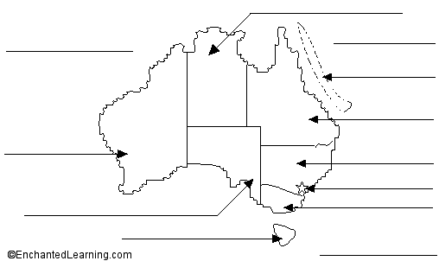

Canberra – Coral Sea
Great Barrier Reef –
Indian Ocean – Victoria –
New South Wales –
Northern Territory –
Queensland – Tasmania –
Tasman Sea –
Western Australia –
South Australia

http://www.enchantedlearning.com/school/Australia/Ausmap.shtml

- Australia is composed of ………………… states and …………………. territories.

- What is the capital city of Australia ? …………………………………………………………………………….

- Which are the largest cities ?………………………………………………………………………………………

………………………………………………………………………………………………………………………….

- How many people are there in Australia ? …………………………………………………………………………

http://www2.lhric.org/pocantico/australia/1.htm

- What is the nickname of Australia ? Why ? ……………………………………………………………………….

- Colour the Australian flag. http://www.enchantedlearning.com/school/Australia/Flagprintout.shtml

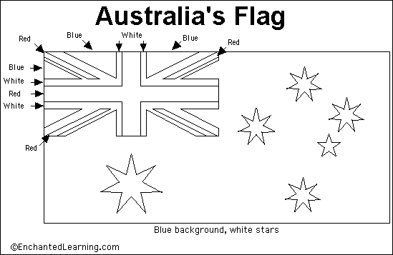

- Why is there the British flag on the upper left corner ? …………………………………………………………..

………………………………………………………………………………………………………………………….

- What do the 5 stars represent ? Why ? ……………………………………………………………………………

…………………………………………………………………………………………………………………………

- What does the Commonwealth star symbolize ? ………………………………………………………………….

………………………………………………………………………………………………………………………….

- What is the currency in Australia ? http://www.effect.net.au/lukastan/oz/2nd.htm

In France, we pay in euros ; In Australia, they pay in ……………………………………………………………….

- Government in Australia. http://www.kidcyber.com.au/topics/austgovt.htm

- Who is the « Head of State » of Australia ? ……………………………………………………………………….

- Who represents her when she is not here ? ………………………………………………………………………..

- Who runs the country ? Who is the Head of the Government ? …………………………………………………..

- The Aborigines. http://www.effect.net.au/lukastan/oz/Aborigines.htm

http://www2.lhric.org/pocantico/australia/2.htm

- Who are they ? ……………………………………………………………………………………………………

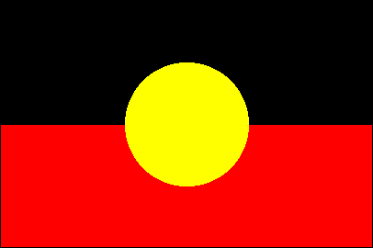
- Look at the Aboriginal flag : http://www.ausflag.com.au/flags/ab.html

The black represents ………………………………………………………………………………………………..

The red represents ………………………………………………………………………………………………….

The yellow represents ………………………………………………………………………………………………

http://www.aboriginalart.com.au/didgeridoo/what_is.html

- What’s a « didgeridoo » ? ………………………………………………………………………………………….

http://www.bumerang-sport.de/story/history.htm

- What was a boomerang used for ? …………………………………………………………………………………

- Ayers rock. http://library.thinkquest.org/28994/places.html and http://www.crystalinks.com/ayersrock.html

- What’s the Aboriginal name of it ? ………………………………………………………………………………

- Why is it so important for the Aborigines ? ………………………………………………………………………

………………………………………………………………………………………………………………………..

- How high, how old and how long is it ? ……………………………………………………………………………

- The Flying doctors. http://www.rfds.org.au/who.htm http://www.rfds.org.au/history.htm

- Who are they ? …………………………………………………………………………………………………….

- What do they do ? ………………………………………………………………………………………………….

- Alice Spring school of the air. http://www2.lhric.org/pocantico/australia/school.htm
http://www.assoa.nt.edu.au/aboutus.html http://www.assoa.nt.edu.au/schoolinfo.html

- What is it ? ………………………………………………………………………………………………………….

…………………………………………………………………………………………………………………………..

- The animals.

- Write the names of these Australian animals. http://www.enchantedlearning.com/subjects/animals/label/australia/labelanswers.shtml

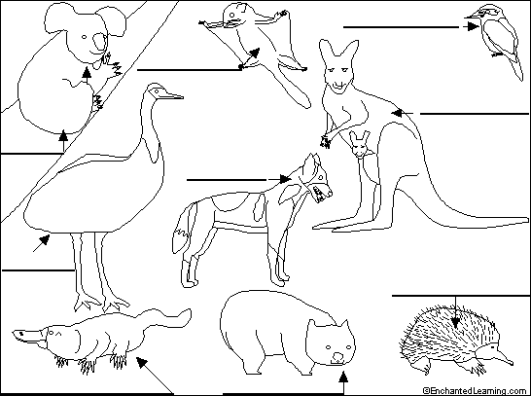

Dingo – Emu -

Duck-billed platypus –

Echidna – Koala -

Kangaroo –

Kookaburra –

Sugar glider –

Wombat -

http://www.enchantedlearning.com/subjects/mammals/dog/Dingocoloring.shtml

- What are « dingoes » ? ………………………………………………………………………………………….

- Where do they live ? …………………………………………………………………………………………….

- What do they eat ? ………………………………………………………………………………………………

http://www.enchantedlearning.com/coloring/Australia.shtml

- Choose an animal and write a few lines about it. …………………………………………………………………

…………………………………………………………………………………………………………………………

…………………………………………………………………………………………………………………………

- Geography and tourism.

http://www2.lhric.org/pocantico/australia/outback.htm

http://www2.lhric.org/pocantico/australia/sheep.htm

- What is the « outback » ? ………………………………………………………………………………………….

- What are there in the outback ? ……………………………………………………………………………………

http://www.kidcyber.com.au/

- What can you see in Sydney ? ……………………………………………………………………………………

…………………………………………………………………………………………………………………………

http://www2.lhric.org/pocantico/australia/reef.htm http://library.thinkquest.org/28994/places.html

- What’s the most famous touristic place near Cairns ? …………………………………………………………….

…………………………………………………………………………………………………………………………

Get more informations on : http://www.timeforkids.com/TFK/specials/goplaces/0,12405,424868,00.html

- Language. http://www2.lhric.org/pocantico/australia/english.htm http://library.thinkquest.org/28994/auswords.html

The Australians speak English but some words or expresssions can be different : it’s the Australian slang.

Can you find the Australian slang words for these English words ?

ENGLISH ➔ AUSTRALIAN AUSTRALIAN ➔ ENGLISH

friend : arvo :

good day : brickies :

work : hoon :

toilet : Oz :

girl : sticky beak :

Australian language : durry :

- Sport. http://www2.lhric.org/pocantico/australia/sport.htm and http://www.webweaver.com.au/australia/sports.html

The Australians are very sporty. What sports do they practice ?

………………………………………………………………………………………………………………………….

………………………………………………………………………………………………………………………….

…………………………………………………………………………………………………………………………

- The 2003 rugby world cup.

http://www.rugby2003.com.au/the_teams/index.asp

- Which group is France in ? Write the other teams. ………………………………………………………………..

………………………………………………………………………………………………………………………….

- Which group is Australia in ? Write the other teams. …………………………………………………………….

………………………………………………………………………………………………………………………..

- Which group is England in ? Write the other teams. …………………………………………………………….

…………………………………………………………………………………………………………………………

- Which group is New-Zealand in ? Write the other teams. ………………………………………………………..

…………………………………………………………………………………………………………………………

Click on the name of the teams to match these emblems to the names of the countries and give the names of the teams.


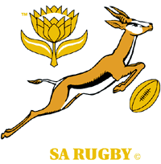
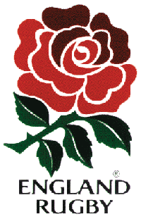
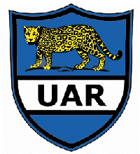

■     

AUSTRALIA - SOUTH AFRICA - ENGLAND - FRANCE - ARGENTINA - NEW-ZEALAND

………………………………………………………………………………………………………………………………………………….
http://www.rugby2003.com.au/schedule/allmatches.asp

When and where will France play ?………………………………………………………………………………….

When and where will Australia play ? ……………………………………………………………………………….

